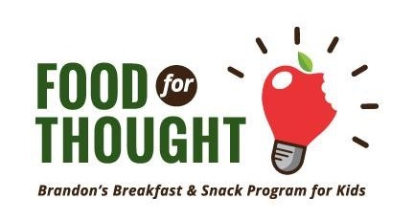
FOOD FOR THOUGHT – BREAKFAST PROGRAM

2025–26 Waiver Form

About the Program
Brandon’s Food for Thought, with the generous help from community partners, offers a breakfast program on school days for students who need extra support due to various reasons including no food access, families working shift work, long bus rides, etc.
The program runs from September 8, 2025 – June 26, 2026. Breakfast is served before school — please check with your school for exact times.
Our aim is to work alongside families, not replace parental responsibility, and to ensure students start the day ready to learn. We follow MB School Nutrition Guidelines and welcome food donations.

Important Notes
- Supervision is available only during program time.
- Regular attendance and good behaviour are required.
- Typical menu: fruit, vegetables, yogurt, cheese, crackers, milk, cereal, bread, bagels, muffins, and grab-and-go items.
- Food is not to be shared. Hand washing is required.

Questions?
Contact: Angie Strachan, Program Coordinator 📞 204-724-2893 | 📧 ang.bfft@gmail.com

Student Information
Name: ______________________________________________________________________________
Birthdate: ___________________________________________________Allergies: _______________________________
School: ___________________________________Grade: ___________Teacher: ________________________________
Parent Name: _______________________________________________Phone: __________________________________
Emergency Contact: ________________________________________Phone: __________________________________

Photo Permission
If you DO NOT want your child’s photo used in media, program materials, or online, please sign:
Parent/Guardian Signature: ________________________________________Date: __________________________

